
ANNA UNIVERSITY REGIONAL CAMPUS,
COIMBATORE-641041

DEPARTMENT OF ELECTRONICS AND COMMUNICATION ENGINEERING
ACADEMIC YEAR 2023-2024 (SEMESTER 5)
IBM NAAN MUDHALVAN CLOUD COMPUTING PROJECT 5: PERSONAL BLOG ON IBM CLOUD STATIC WEB APP
PHASE 5: DEVELOPMENT PART 3

DONE BY,
SRI HARIHARAN B
710021106306
PROJECT NAME: PERSONAL BOLG ON IBM CLOUD STATIC WEB APPS
PHASE- 5: PROJECT DOCUMENTATION & SUBMISSION

TRAVEL ADVENTURES
AIM:
To create an inspiring platform where travel enthusiasts can share their adventures, tips and photos to encourage others to explore the world and create unforgettable memories.
VISION:
Our vision is to create a travel blog that goes beyond the conventional boundaries. we aim to inspire, educate and connect travellers through innovative approaches, offering them a glimpse into the future of travel exploration.

PROJECT GOALS:
Design a user friendly blog structure and producing engaging content like high quality and informative content that captures the essence of travel experiences and provides valuable insights to readers

BLOG STRUCTURE:
HOME PAGE:
Welcome visitor showcase featured travel destination, and highlight recent posts.
TRAVEL STORIES:
Categorize travel experiences by destinations, allowing readers to explore specific regions or countries.
TRAVEL TIPS:
Provide practical tips, packing guides, and travel hacks to assist readers in planning their tips effectively.
PHOTO GALLERY:
Curate a visually appealing gallery displaying high – resolution photos from various travel adventures.

ABOUT ME:
Share a personal story about the travel and background information to connect with readers on a personal level
CONTACT:
Include a contact form or social media links for readers to reach out, provide feedback or ask questions.

CONTENT STRATEGY:
ENGAGING TRAVEL NARRATIVES:
Write detailed and engaging travel stories sharing personal experiences cultural discoveries and memorable encounters.
STUNNING VISUALS:
Accompany each blog post with high quality and captivating photos to enhance the visual appeal and immerse readers in the travel experiences.
PRACTICAL TIPS:
Offer practical travel tips, budgeting advice local cuisine recommendations and safety guidelines to help readers plan their trips effectively.
INTERACTIVE ELEMENTS:
Incorporate interactive elements such as maps, quizzes, or polls to engage readers and encourage participation

KEY INNOVATIONS:
AUGMENTED REALITY TRAVEL GUIDES:
AR city guides – through AR technologies readers can experience virtual city tours. By scanning landmarks with their smart phones they instantly the access historical facts local legends and hidden gems.
LIVE VR TRAVEL EVENTS:
Host live VR events enabling readers to participate in real time travel experiences. they can explore attend festivals or even join cooking classes from the comfort of their homes.

BLOCKCHAIN-POWERED TRAVEL SAFETY:
Secure travel profiles-implement block chain technology to create secure traveller profiles ensuring that personal information and preferences are protected
Smart contract for travel services-utilize smart contracts for secure and transparent booking of accommodations transportation and tours enhancing trust between travellers and service providers
3D INTERACTIVE MAP:
Incorporate 3D map were radars can zoom, rotate and explore destinations in detail, enhancing their understanding of the geography.
INTERACTIVE QUIZZES:
Create interactive quizzes that assess readers travel performances and suggest customized destination and activities based on their responses.

LANGUAGES USED IN CODING:
MARKUP LANGUAGE:
HTML (Hypertext Markup Language)
CSS (Cascading Style Sheets)
JAVASCRIPT
HTML:
Purpose- HTML is the backbone of web content. It provides the structure and semantic meaning to the elements on the web page
Function-HTML is used to create the fundamental structure of web page, defining elements like heading, paragraph, links, images, forms and more.
Its content in a way that browses can interpret and display properly
CSS:
Purpose-CSS complements HTML by controlling the presentation and styling of web content. It separates the design from the structure
Function-CSS responsible for defining the visual aspects of a web page, such as layout, colours, fonts, spacing and positioning. It allows for consistent and aesthetically pleasing design across a website.

CODING:

<!DOCTYPE html>
<html>
<head>
<title>Travel Website</title>
<link rel="preconnect" href="https://fonts.gstatic.com">
<link href="https://fonts.googleapis.com/css2?family=Poppins:wght@300&display=swap" rel="stylesheet">
<link rel="stylesheet" type="text/css" href="./style.css">
</head>
<body>
<div class="navbar">
<div class="logo">
<h1>Travel</h1>
</div>
<div class="menu">
<ul>
<li><a href="#">HOME</a></li>
<li><a href="./travel/html.html">TRAVEL STORIES</a></li>
<li><a href="./photogallery.html">TRAVEL TIPS</a></li>
<li><a href="./sidebar/index.html">PHOTO GALLERY</a></li>
<li><a href="./map.html">MAP</a></li>
<li><a href="./contact.html">CONTACT</a></li>

<li><a href="#">ABOUT ME</a></li>
</ul>
</div>
<div class="signup">
<a href="#">Sign Up</a>
</div>
</div>
<div class="body">
<div class="heading">
<h1>Travel With Us</h1>
<br>
<p>ipsum dolor sit amet, consectetur adipisicing elit, sed do eiusmod
tempor incididunt ut labore et dolore magna aliqua. </p>
<br>
<br>
<a href="#">Learn More</a>
</div>
<div class="tours">
<div class="places">
<h2>Australia</h2>
<img src="img1.jpg" style="width: 300px; height: 250px; border-radius: 12px;">
<br>
<br>
<a href="#">Book Now 15% OFF</a>
</div>
<div class="places">
<h2>New York</h2>
<img src="img2.jpg" style="width: 300px; height: 250px; border-radius: 12px;">
<br>
<br>
<a href="#">Book Now 20% OFF</a>
</div>
<div class="places">
<h2>Thailand</h2>
<img src="img3.jpg" style="width: 300px; height: 250px; border-radius: 12px;">
<br>
<br>
<a href="#">Book Now 25% OFF</a>
</div>
</div>
</div>
<div class="footer">
<a href="#">Copyright</a>
<a href="#">Terms and Conditions</a>
<a href="#">Privacy Policy</a>
<a href="#">Cookies</a>
<a href="#">Complaints</a>
</div>
</body>
</html>

Contact.html:
<!DOCTYPE html>
<html lang="en">
<head>
<meta charset="UTF-8">
<meta name="viewport" content="width=device-width, initial-scale=1.0">
<title>Document</title>
</head>
<body>
<!DOCTYPE html>
<html lang="en">

<head>
<meta charset="UTF-8">
<meta name="viewport" content="width=device-width, initial-scale=1.0">
<title>Bulma Contact Form</title>
<link rel="stylesheet" href="https://cdn.jsdelivr.net/npm/bulma@0.9.3/css/bulma.min.css">
</head>

<body>
<section class="section">
<div class="container">
<h1 class="title">fabform.io bulma form</h1>
<div class="columns">
<div class="column is-half">
<form action="https://fabform.io/f/{insert-your-form-id}" method="post">
<div class="field">
<label class="label">Name</label>
<div class="control">
<input class="input" type="text" placeholder="Your Name">
</div>
</div>
<div class="field">
<label class="label">Email</label>
<div class="control">
<input class="input" type="email" placeholder="Your Email">
</div>
</div>
<div class="field">
<label class="label">Message</label>
<div class="control">
<textarea class="textarea" placeholder="Your Message"></textarea>
</div>
</div>
<div class="field">
<div class="control">
<button class="button is-primary">Submit</button>
<p>Powered by <a href="https://fabform.io" target="_blank">fabform.io</a></p>
</div>
</div>
</form>
</div>
</div>
</div>
</section>
</body>

</html>
</body>
</html>

Map.html:
<!-- <script src="https://www.amcharts.com/lib/3/ammap.js" type="text/javascript"></script>
<script src="https://www.amcharts.com/lib/3/maps/js/worldHigh.js" type="text/javascript"></script>
<script src="https://www.amcharts.com/lib/3/themes/dark.js" type="text/javascript"></script>
<div id="mapdiv" style="width:100%; height:100vh;"></div>

<script type="text/javascript">
var map = AmCharts.makeChart("mapdiv",{
type: "map",

projection: "mercator",
panEventsEnabled : true,
backgroundColor : "#535364",
backgroundAlpha : 1,
zoomControl: {
zoomControlEnabled : true
},
dataProvider : {
map : "worldHigh",
getAreasFromMap : true,
areas :
[
{
"id": "CA",
"showAsSelected": true
},
{
"id": "US",
"showAsSelected": true
},
{
"id": "AE",
"showAsSelected": true
},
{
"id": "IN",
"showAsSelected": true
},
{
"id": "MY",
"showAsSelected": true
},
{
"id": "QA",
"showAsSelected": true
},
{
"id": "TH",
"showAsSelected": true
},
{
"id": "SG",
"showAsSelected": true
}
]
},
areasSettings : {
autoZoom : true,
color : "#B4B4B7",
colorSolid : "#84ADE9",
selectedColor : "#84ADE9",
outlineColor : "#666666",
rollOverColor : "#9EC2F7",
rollOverOutlineColor : "#000000"
}
});
</script>
-->
<!DOCTYPE html>
<html lang="en">
<head>
<meta charset="UTF-8">
<meta name="viewport" content="width=device-width, initial-scale=1.0">
<title>Document</title>
</head>
<body>
<iframe src="https://www.google.com/maps/embed?pb=!1m14!1m12!1m3!1d15651.33692213242!2d77.57339365!3d11.27359315!2m3!1f0!2f0!3f0!3m2!1i1024!2i768!4f13.1!5e0!3m2!1sen!2sin!4v1697622093176!5m2!1sen!2sin" width="100%" height="800px" style="border:0;" allowfullscreen="" loading="lazy" referrerpolicy="no-referrer-when-downgrade"></iframe>
</body>
</html>

Css:
*{
padding: 0px;
margin: 0px;
box-sizing: border-box;
list-style: none;
font-family: 'Poppins', sans-serif;

}
.navbar{
width: 100%;
height: 80px;
background-color: #fee;
display: flex;
justify-content: space-around;
align-items: center;
color: #000;
}
.menu ul{
display: flex;
align-items: center;
}
.menu ul li a{
text-decoration: none;
color: #000;
padding: 5px 12px;
letter-spacing: 2px;
font-size: 18px;
}
.menu ul li a:hover{
border-bottom: 4px solid #000;
transition: 0.4s;
}
.signup a{
text-decoration: none;
color: #000;
font-size: 18px;
font-weight: bold;
border-radius: 12px;
padding: 12px 30px;
border: 2px solid #ff0000;
}
.signup a:hover{
background-color: red;
transition: 0.6s;
}
.body{
width: 100%;
height: 90vh;
display: flex;
justify-content: space-around;
align-items: center;
background-image: linear-gradient(rgba(0,0,0,0.50),rgba(0,0,0,0.50)),url(img1.jpg);
background-position: center;
background-size: cover;
}
.heading{
width: 30%;
text-align: center;
color: #fff;
}
.heading h1{
font-size: 40px;
}
.heading a{
text-decoration: none;
color: #000;
font-size: 25px;
font-weight: bold;
border-radius: 45px;
padding: 14px 50px;
background-color: #fff;
}
.heading a:hover{
letter-spacing: 3px;
transition: 0.6s;
}
.tours{
width: 70%;
display: flex;
justify-content: space-around;
}
.places{
display: inline;
text-align: center;
border-radius: 12px;
}
.places h2{
color: red;
font-size: 35px;
letter-spacing: 3px;
border-radius: 1px;
padding: 30px 30px;
background-color: #000;
}
.places a{
text-decoration: none;
color: red;
font-weight: bold;
font-size: 18px;
border-radius: 12px;
padding: 12px 30px;
background-color: #fff;
}
.places a:hover{
background-color: #000;
letter-spacing: 3px;
transition: 0.6s;
}
.footer{
width: 100%;
height: 50px;
display: flex;
justify-content: space-around;
align-items: center;
}
.footer a{
text-decoration: none;
color: green;
font-size: 18px;
font-weight: bold;
}
.footer a:hover{
text-decoration: underline;
transition: 0.4s;
}

PHOTO GALLERY:

@import url("https://fonts.googleapis.com/css2?family=EB+Garamond:ital,wght@0,400;0,500;0,600;1,400;1,500;1,600&display=swap");

body {
max-width: 800px;
margin: 0 auto;
background: #e7dfcf;
}

section {
margin: 80px 0;
display: grid;
grid-template-areas: "title title img3 img3"
"img2 img1 img3 img3";
grid-gap: 8px;
}

h2 {
grid-area: title;
color: #111;
font-size: 120px;
font-family: "EB Garamond", serif;
font-weight: normal;
margin: 0 0 20px 0;
position: relative;
z-index: 1;
line-height: 1;
mix-blend-mode: hard-light;
max-width: 240px;

}
h2 span {
font-weight: bold;
}

h2::after {
display: none;
content: "";
height: 8px;
border-radius: 30px;
width: 70%;
/* display: block; */
background: currentColor;
transition: 0.5s ease;
}

h2:hover::after {
transform: translateX(50%);
}

section img:nth-child(4) {
grid-area: img3;
aspect-ratio: 3 / 4;
}
section img:nth-child(1) {
grid-area: img1;
}
section img:nth-child(2) {
grid-area: img2;
}
section img {
aspect-ratio: 4 / 3;
}

img {
max-width: 100%;
width: 100%;
height: 100%;
border-radius: 5px;
object-fit: cover;
transition: 0.3s ease;
box-shadow: 0 1px 3px 0 rgb(0 0 0 / 0.1), 0 1px 2px -1px rgb(0 0 0 / 0.1);
}

IMAGES:
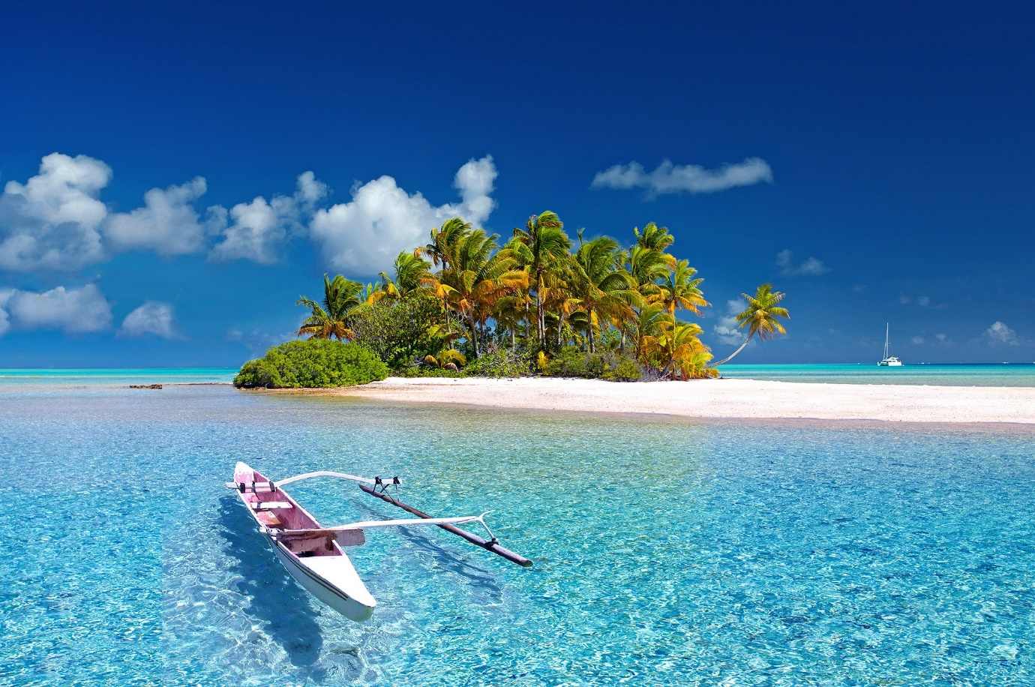

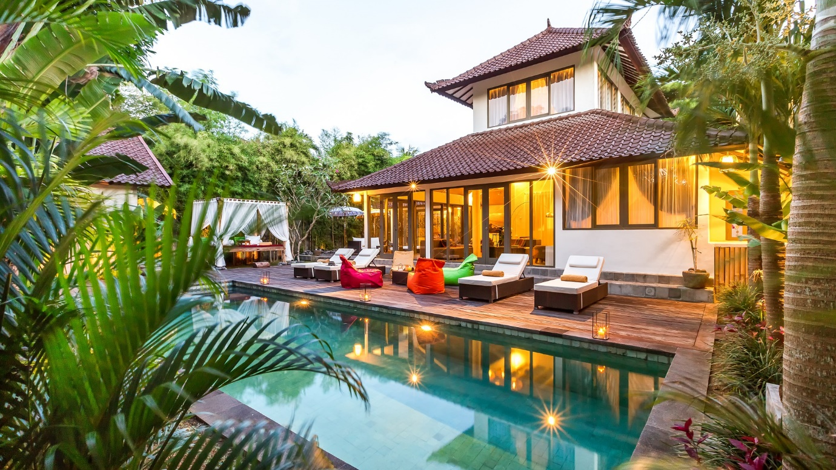

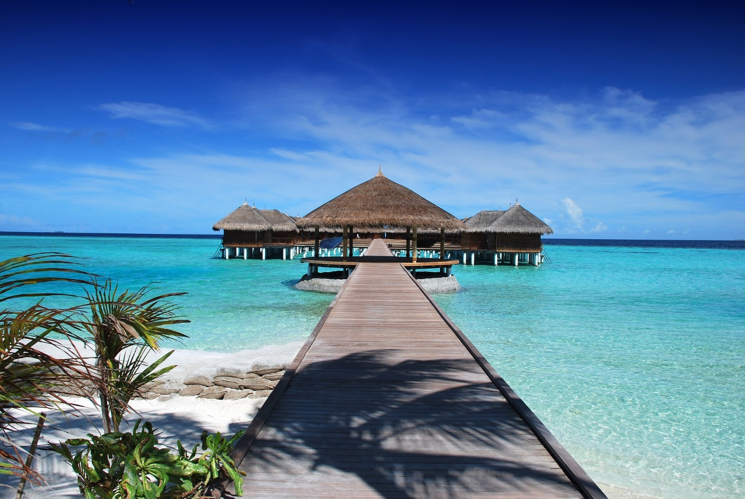

MAP:

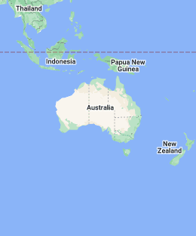

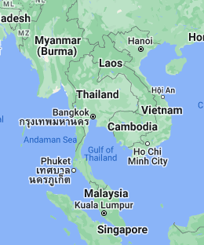

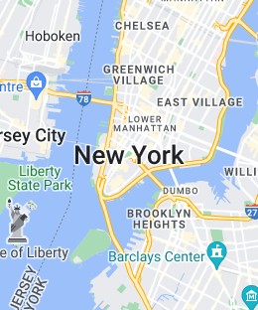

OUTPUT:
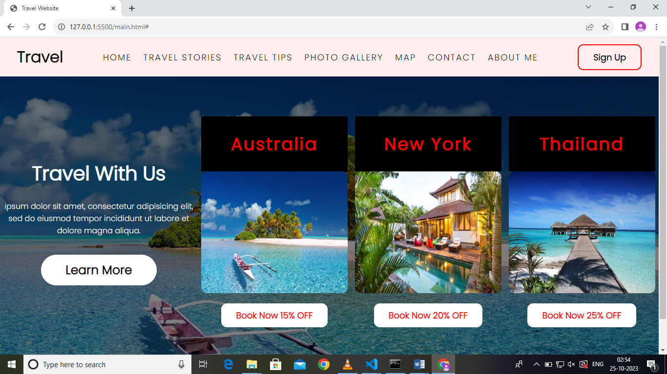

GENERATED LINK:
http://127.0.0.1:5500/Personal%20Blog%20on%20IBM%20cloud%20static%20web%20Apps.html

CONCLUSION:
Inspiring tomorrows explores our innovative travel blog project is not just a blog; it’s a glimpse into the future of travel. by embracing emerging technologies, fostering community engagement, and prioritizing user experiences, we are inspiring a new generation of travellers. Through this project we are not just sharing a stories; we are shaping the future of global exploration –one innovative adventure at a time.

